**Exercise 3: Stored Procedures**

**Scenario 1:** The bank needs to process monthly interest for all savings accounts.

* + **Question:** Write a stored procedure **ProcessMonthlyInterest** that calculates and updates the balance of all savings accounts by applying an interest rate of 1% to the current balance.

**Procedure:**

CREATE OR REPLACE PROCEDURE ProcessMonthlyInterest IS

BEGIN

UPDATE Accounts

SET Balance = Balance + (Balance * 0.01)

WHERE AccountType = 'Savings';

COMMIT;

END;

/

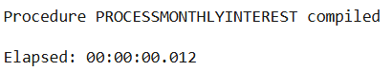

BEGIN

ProcessMonthlyInterest;

END;

/

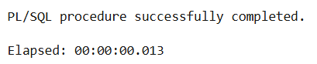

**Scenario 2:** The bank wants to implement a bonus scheme for employees based on their performance.

* + **Question:** Write a stored procedure **UpdateEmployeeBonus** that updates the salary of employees in a given department by adding a bonus percentage passed as a parameter.

**Procedure:**

CREATE OR REPLACE PROCEDURE UpdateEmployeeBonus (

p_dept_id IN NUMBER,

p_bonus_pct IN NUMBER

) IS

BEGIN

UPDATE Employees

SET Salary = Salary + (Salary * p_bonus_pct / 100)

WHERE DepartmentID = p_dept_id;

COMMIT;

END;

/

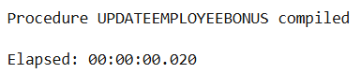

BEGIN

UpdateEmployeeBonus(10, 10);

END;

/

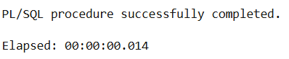

**Scenario 3:** Customers should be able to transfer funds between their accounts.

* + **Question:** Write a stored procedure **TransferFunds** that transfers a specified amount from one account to another, checking that the source account has sufficient balance before making the transfer.

**Procedure:**

CREATE OR REPLACE PROCEDURE TransferFunds (

p_from_acc IN NUMBER,

p_to_acc IN NUMBER,

p_amount IN NUMBER

) IS

v_balance NUMBER;

BEGIN

SELECT Balance INTO v_balance

FROM Accounts

WHERE AccountID = p_from_acc

FOR UPDATE;

IF v_balance >= p_amount THEN

UPDATE Accounts

SET Balance = Balance - p_amount

WHERE AccountID = p_from_acc;

UPDATE Accounts

SET Balance = Balance + p_amount

WHERE AccountID = p_to_acc;

COMMIT;

ELSE

RAISE_APPLICATION_ERROR(-20001, 'Insufficient balance in source account');

END IF;

END;

/

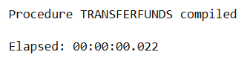

BEGIN

TransferFunds(104, 105, 5000); -- Transfer 5000 from Diana to Bruce

END;

/

